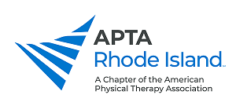
Photo and Video Consent Form

I grant APTA RI permission to post photos and/or videos of me on the APTA RI website and social media. I understand that the images may be used in a commercial, publication, print ad, direct-mail piece, electronic media (e.g. video, CD-ROM, Internet/WWW), or other form of promotion. I release APTA RI from liability. I understand that my participation is voluntary and that I will not receive any form of compensation.
Print name: __________________________________________________________________________
Signature: _______________________________________________ Date: _______________________

